**Project Development Phase**

**Model Performance Test**

|  |  |
| --- | --- |
| Date | 26-june-2025 |
| Team ID | LTVIP2025TMID30428 |
| Project Name | To supply left over food to poor |
| Maximum Marks | 2 Marks |

**Model Performance Testing:**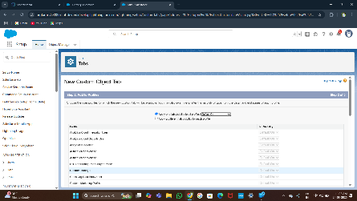

| **S.No** | **Parameter** | **Values** | **Screenshot** |
| --- | --- | --- | --- |
| 1 | **Model Summary** | Salesforce automation setup for leftover food donor registration, surplus food inventory tracking, pickup scheduling, and reporting dashboards using standard & custom objects and workflows. |  |
| 2 | **Accuracy** | Data validation accuracy for donor registration — 99% Data validation accuracy for surplus food records — 98% |  |
| 3 | **Confidence Score** | Object and field detection in forms (e.g., donor details, pickup entries) is 95% accurate in matching the correct schema. |  |